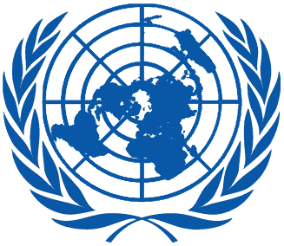 | Working Group on the Universal Periodic Review
Thirty-seventh session
Geneva, 18–29 January 2021
Order of the Day
Plenary Meetings Assembly Hall
Friday, 22 January 2021
MORNING
9:00 – 12:30  9th meeting |  | UPR of Austria  - National Report of Austria in accordance with paragraph 15 (a) of the annex to HRC resolution 5/1 and paragraph 5 of the annex to HRC resolution 16/21: A/HRC/WG.6/37/AUT/1  - Compilation prepared by the OHCHR in accordance with paragraph 15 (b) of the annex to HRC resolution 5/1 and paragraph 5 of the annex to HRC resolution 16/21: A/HRC/WG.6/37/AUT/2  - Summary prepared by the OHCHR in accordance with paragraph 15 (c) of the annex to HRC resolution 5/1 and paragraph 5 of the annex to HRC resolution 16/21: A/HRC/WG.6/37/AUT/3
AFTERNOON
15:00 – 18:00  10th meeting |  | Adoption of the recommendations section on:
Federated States of Micronesia
- Draft report of the UPR Working Group: A/HRC/WG.6/37/L.1
Lebanon
- Draft report of the UPR Working Group: A/HRC/WG.6/37/L.2
Mauritania
- Draft report of the UPR Working Group: A/HRC/WG.6/37/L.3
Saint Kitts and Nevis
- Draft report of the UPR Working Group: A/HRC/WG.6/37/L.4
Australia
- Draft report of the UPR Working Group: A/HRC/WG.6/37/L.5
Saint Lucia
- Draft report of the UPR Working Group: A/HRC/WG.6/37/L.6
Notes:
All speakers scheduled to take the floor should upload the written version of their oral statements through the online system for inscription on the lists of speakers (https://uprreg.ohchr.org/) before the opening of the review.
- The full text of statements is available on UPR extranet page
- Identity photo-badges valid for the session may be obtained by all delegations, if needed, from the UNOG Security and Safety Section at the “Pregny Gate” (Palais des Nations, 8-14 avenue de la Paix) from 8.00 a.m. to 5.00 p.m. upon presentation of a copy of their letter of accreditation and an identity document.
- PHOTOGRAPHS AND FILMING: Please note that only accredited media are permitted to film and take photographs in the Assembly Hall.

