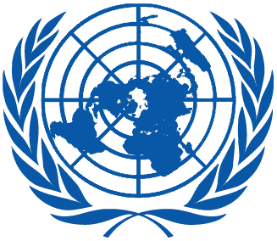 | Working Group on the Universal Periodic Review
Thirty-fifth session
Geneva, 20–31 January 2020

Order of the Day
Plenary Meetings – Room XX
Thursday, 23 January 2020
MORNING
9:00 – 12:30  6th meeting |  | UPR of Kenya  - National report of Kenya: A/HRC/WG.6/35/KEN/1  - Compilation prepared by the OHCHR in accordance with paragraph 15 (b) of the annex to HRC resolution 5/1 and paragraph 5 of the annex to HRC resolution 16/21: A/HRC/WG.6/35/KEN/2  - Summary prepared by the OHCHR in accordance with paragraph 15 (c) of the annex to HRC resolution 5/1 and paragraph 5 of the annex to HRC resolution 16/21: A/HRC/WG.6/35/KEN/3
AFTERNOON
14:30 – 18:00  7th meeting |  | UPR of Armenia  - National report of Armenia: A/HRC/WG.6/35/ARM/1  - Compilation prepared by the OHCHR in accordance with paragraph 15 (b) of the annex to HRC resolution 5/1 and paragraph 5 of the annex to HRC resolution 16/21: A/HRC/WG.6/35/ARM/2  - Summary prepared by the OHCHR in accordance with paragraph 15 (c) of the annex to HRC resolution 5/1 and paragraph 5 of the annex to HRC resolution 16/21: A/HRC/WG.6/35/ARM/3
Notes:
All speakers scheduled to take the floor should provide the Secretariat beforehand with copies of the statements.
- The full text of statements is available on UPR extranet page
- Identity photo-badges valid for the session may be obtained by all delegations, if needed, from the UNOG Security and Safety Section at the “Pregny Gate” (Palais des Nations, 8-14 avenue de la Paix) from 8.00 a.m. to 5.00 p.m. upon presentation of a copy of their letter of accreditation and an identity document.
- PHOTOGRAPHS AND FILMING: Please note that only accredited media are permitted to film and take photographs in Room XX.

