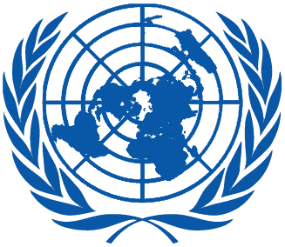 | Working Group on the Universal Periodic Review
Thirty-fourth session
Geneva, 4–15 November 2019

Order of the Day
Plenary Meetings – Room XX
Tuesday, 5 November 2019
MORNING
9:00 – 12:30  3rd meeting |  | UPR of the Gambia  - National report of the Gambia: A/HRC/WG.6/34/GMB/1  - Compilation prepared by the OHCHR in accordance with paragraph 15 (b) of the annex to HRC resolution 5/1 and paragraph 5 of the annex to HRC resolution 16/21: A/HRC/WG.6/34/GMB/2  - Summary prepared by the OHCHR in accordance with paragraph 15 (c) of the annex to HRC resolution 5/1 and paragraph 5 of the annex to HRC resolution 16/21: A/HRC/WG.6/34/GMB/3
AFTERNOON
14:30 – 18:00  4th meeting |  | UPR of the Plurinational State of Bolivia  - National report of the Plurinational State of Bolivia: A/HRC/WG.6/34/BOL/1  - Compilation prepared by the OHCHR in accordance with paragraph 15 (b) of the annex to HRC resolution 5/1 and paragraph 5 of the annex to HRC resolution 16/21: A/HRC/WG.6/34/BOL/2  - Summary prepared by the OHCHR in accordance with paragraph 15 (c) of the annex to HRC resolution 5/1 and paragraph 5 of the annex to HRC resolution 16/21: A/HRC/WG.6/34/BOL/3
Notes:
All speakers scheduled to take the floor should provide the Secretariat beforehand with copies of the statements.
- The full text of statements is available on UPR extranet page
- Identity photo-badges valid for the session may be obtained by all delegations, if needed, from the UNOG Security and Safety Section at the “Pregny Gate” (Palais des Nations, 8-14 avenue de la Paix) from 8.00 a.m. to 5.00 p.m. upon presentation of a copy of their letter of accreditation and an identity document.
- PHOTOGRAPHS AND FILMING: Please note that only accredited media are permitted to film and take photographs in Room XX.

