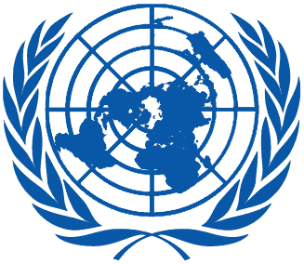 | Working Group on the Universal Periodic Review
Thirty-third session
Geneva, 6–17 May 2019
Order of the Day
Plenary Meetings – Room XX
Friday, 10 May 2019
MORNING
9:00 – 12:30  9th meeting |  | UPR of Brunei Darussalam  - National Report of Brunei Darussalam: A/HRC/WG.6/33/BRN/1  - Compilation prepared by the OHCHR in accordance with paragraph 15 (b) of the annex to HRC resolution 5/1 and paragraph 5 of the annex to HRC resolution 16/21: A/HRC/WG.6/33/BRN/2  - Summary prepared by the OHCHR in accordance with paragraph 15 (c) of the annex to HRC resolution 5/1 and paragraph 5 of the annex to HRC resolution 16/21: A/HRC/WG.6/33/BRN/3
AFTERNOON
15:00 – 18:00  10th meeting |  | Adoption of the recommendations section on:
Norway
- Draft report of the UPR Working Group: A/HRC/WG.6/33/L.1
Albania
- Draft report of the UPR Working Group: A/HRC/WG.6/33/L.2
Democratic Republic of the Congo
- Draft report of the UPR Working Group: A/HRC/WG.6/33/L.3
Côte d’Ivoire
- Draft report of the UPR Working Group: A/HRC/WG.6/33/L.4
Portugal
- Draft report of the UPR Working Group: A/HRC/WG.6/33/L.5
Bhutan
- Draft report of the UPR Working Group: A/HRC/WG.6/32/L.6
Notes:
All speakers scheduled to take the floor should provide the Secretariat beforehand with copies of the statements.
- The full text of statements is available on UPR extranet page
- Identity photo-badges valid for the session may be obtained by all delegations, if needed, from the UNOG Security and Safety Section at the “Pregny Gate” (Palais des Nations, 8-14 avenue de la Paix) from 8.00 a.m. to 5.00 p.m. upon presentation of a copy of their letter of accreditation and an identity document.
- PHOTOGRAPHS AND FILMING: Please note that only accredited media are permitted to film and take photographs in Room XX.

