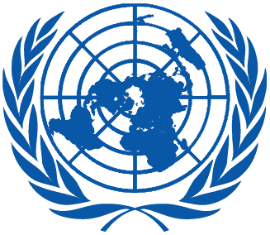 | Working Group on the Universal Periodic Review
Twenty-eighth session
Geneva, 6–17 November 2017

Order of the Day
Plenary Meetings – Room XX
Tuesday, 7 November 2017
MORNING
9:00 – 12:30  3rd meeting |  | UPR of Gabon  - National report of Gabon: A/HRC/WG.6/28/GAB/1  - Compilation prepared by the OHCHR in accordance with paragraph 15 (b) of the annex to HRC resolution 5/1 and paragraph 5 of the annex to HRC resolution 16/21: A/HRC/WG.6/28/GAB/2  - Summary prepared by the OHCHR in accordance with paragraph 15 (c) of the annex to HRC resolution 5/1 and paragraph 5 of the annex to HRC resolution 16/21: A/HRC/WG.6/28/GAB/3
AFTERNOON
14:30 – 18:00  4th meeting |  | UPR of Ghana  - National report of Ghana: A/HRC/WG.6/28/GHA/1  - Compilation prepared by the OHCHR in accordance with paragraph 15 (b) of the annex to HRC resolution 5/1 and paragraph 5 of the annex to HRC resolution 16/21: A/HRC/WG.6/28/GHA/2  - Summary prepared by the OHCHR in accordance with paragraph 15 (c) of the annex to HRC resolution 5/1 and paragraph 5 of the annex to HRC resolution 16/21: A/HRC/WG.6/28/GHA/3
Notes:
All speakers scheduled to take the floor should provide the Secretariat beforehand with copies of the statements.
- The full text of statements is available: UPR extranet page
- Identity photo-badges valid for the session may be obtained by all delegations, if needed, from the UNOG Security and Safety Section at the “Pregny Gate” (Palais des Nations, 8-14 avenue de la Paix) from 8.00 a.m. to 5.00 p.m. upon presentation of a copy of their letter of accreditation and an identity document.
- PHOTOGRAPHS AND FILMING: Please note that only accredited media are permitted to film and take photographs in Room XX.

