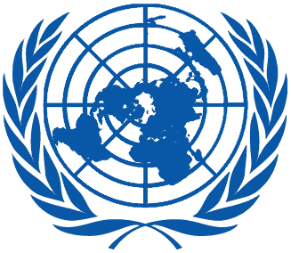 | Working Group on the Universal Periodic Review
Twenty-seventh session
Geneva, 1–12 May 2017

Order of the Day
Plenary Meetings – Room XX
Friday, 12 May 2017
AFTERNOON
17:00 – 18:00  18th meeting |  | Adoption of the recommendations section on:
The Netherlands
– Draft report of the UPR Working Group: A/HRC/WG.6/27/L.13
 |  | South Africa
 |  | – Draft report of the UPR Working Group: A/HRC/WG.6/27/L.14
Notes:
All speakers scheduled to take the floor should provide the Secretariat beforehand with 25 copies of the statements. For general distribution, 250 copies are needed.
- The full text of statements is available: UPR extranet page
- Identity photo-badges valid for the session may be obtained by all delegations, if needed, from the UNOG Security and Safety Section at the “Pregny Gate” (Palais des Nations, 8-14 avenue de la Paix) from 8.00 a.m. to 5.00 p.m. upon presentation of a copy of their letter of accreditation and an identity document.
- PHOTOGRAPHS AND FILMING: Please note that only accredited media are permitted to film and take photographs in Room XX.

