§§
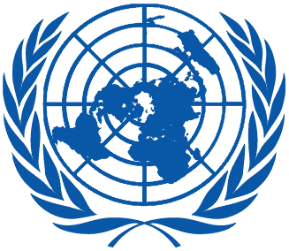 | Working Group on the Universal Periodic Review
Twenty-sixth session
Geneva, 31 October–11 November 2016
Order of the Day
Plenary Meetings – Room XX
Friday, 4 November 2016
MORNING
9:00 – 12:30  9th meeting |  | UPR of the Republic of Moldova  - National Report of the Republic of Moldova: A/HRC/WG.6/26/MDA/1  - Compilation prepared by the OHCHR in accordance with paragraph 15 (b) of the annex to HRC resolution 5/1 and paragraph 5 of the annex to HRC resolution 16/21: A/HRC/WG.6/26/MDA/2  - Summary prepared by the OHCHR in accordance with paragraph 15 (c) of the annex to HRC resolution 5/1 and paragraph 5 of the annex to HRC resolution 16/21: A/HRC/WG.6/26/MDA/3
AFTERNOON
15:00 – 18:00  10th meeting |  | Adoption of the recommendations section on:
Togo
- Draft report of the UPR Working Group: A/HRC/WG.6/26/L.1
Syrian Arab Republic
- Draft report of the UPR Working Group: A/HRC/WG.6/26/L.2
Bolivarian Republic of Venezuela
- Draft report of the UPR Working Group: A/HRC/WG.6/26/L.3
Iceland
- Draft report of the UPR Working Group: A/HRC/WG.6/26/L.4
Zimbabwe
- Draft report of the UPR Working Group: A/HRC/WG.6/26/L.5
Lithuania
- Draft report of the UPR Working Group: A/HRC/WG.6/26/L.6
Notes:
All speakers scheduled to take the floor should provide the Secretariat beforehand with 25 copies of the statements. For general distribution, 250 copies are needed.
- The full text of statements are available: UPR extranet page
- Click on the following link to install the UNHRC iPad App:
https://build.phonegap.com/apps/529195/install
- Identity photo-badges valid for the session may be obtained by all delegations, if needed, from the UNOG Security and Safety Section at the “Pregny Gate” (Palais des Nations, 8-14 avenue de la Paix) from 8.00 a.m. to 5.00 p.m. upon presentation of a copy of their letter of accreditation and an identity document.
- PHOTOGRAPHS AND FILMING: Please note that only accredited media are permitted to film and take photographs in Room XX.

