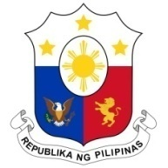
PHILIPPINES

Human Rights Council
36th Session of the Working Group on the Universal Periodic Review
09 November 2020, General Assembly Hall, Palais des Nations

UNITED STATES OF AMERICA

Speaking Time: 55 sec
Speaking Order: 111 of 123

Thank you, Chair.

The Philippines warmly welcomes the delegation of the United States of America to this UPR session.

We acknowledge the USA's constructive approach to the UPR process and notes efforts made in implementing the accepted recommendations from the last cycle.

We express our appreciation for the efforts of the US government to combat trafficking in persons and encourage it to continue working with different countries in addressing the issue.

In a constructive spirit, the Philippines presents the following recommendations for consideration by the USA:

- Take steps towards the establishment of a national human rights institution in accordance with the Paris Principles;

- Ratify the following treaties which it signed: the ICESR, CRC, and CEDAW; and

- Sign the ICRMW.

We wish the USA every success in this review cycle.

Thank you, Chair. END.

