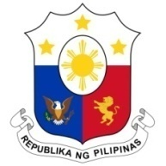
PHILIPPINES

Human Rights Council
36th Session of the Working Group on the Universal Periodic Review
04 November 2020, Salle XIX, Palais des Nations

MALDIVES

Speaking Time: 1 min 10 sec
Speaking Order: 87 of 98

Thank you, Chair.

The Philippines warmly welcomes the delegation of Maldives to this UPR session.

We are pleased to note the adoption of laws aimed at strengthening human rights promotion and protection such as the Gender Equality Act, and National Wage Policy Act, among others.

We also acknowledge the government's efforts to strengthen its national development planning process towards achieving an inclusive, sustainable and decentralized development.

In a constructive spirit, the Philippines presents the following recommendations for consideration by Maldives:

- Continue undertaking awareness-raising and capacity-building programs to prevent and address domestic violence and ensure provision of adequate assistance to victims;

- Continue mainstreaming gender perspective in climate adaptation and mitigation measures;

- Consider ratifying the ICRMW – the Migrant Workers Convention; and

- Consider ratifying the ILO Convention No. 189.
We wish Maldives every success in this review cycle.
Thank you, Chair. END

