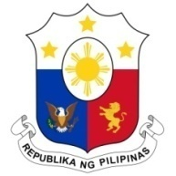
PHILIPPINES

Human Rights Council
36th Session of the Working Group on the Universal Periodic Review
05 November 2020, Salle XIX, Palais des Nations

HONDURAS

Speaking Time: 1 min 20 sec
Speaking Order: 40 of 87

Thank you, Chair.

The Philippines warmly welcomes the delegation of Honduras to this UPR session.

We recognize Honduras' constructive approach to the UPR process and we are pleased to note the progress made in the implementation of the accepted recommendations from the last cycle.

We welcome the efforts made by the government especially in the areas of promoting sustainable development, financial inclusion, and strengthening social protection for vulnerable groups.

In a constructive spirit, the Philippines presents the following recommendations for consideration by Honduras:

- Continue to implement and strengthen its programs on developing human capital through entrepreneurship and conditional transfers that prioritize vulnerable groups;

- Redouble its efforts in preventing and addressing violence against women, to punish those responsible and to provide assistance and protection to victims; and

- Ensure the meaningful political participation of indigenous peoples and their access to social services.

We wish Honduras every success in implementing all its accepted recommendations.

Thank you, Chair. END.

