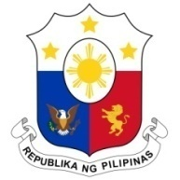
PHILIPPINES

Human Rights Council
36th Session of the Working Group on the Universal Periodic Review
06 November 2020, Salle XIX, Palais des Nations

BULGARIA

Speaking Time: 1 min 10 sec
Speaking Order: 28 of 96

Thank you, Chair.

The Philippines warmly welcomes the delegation of Bulgaria to this UPR session.

We recognize the progress made in the implementation of its human rights obligations since the last UPR cycle.

We welcome, in particular, the accreditation of the Institution of the Ombudsman of Bulgaria with "A" status in full compliance with the Paris Principles.

In a constructive spirit, the Philippines recommends the following:

- Intensify efforts in human rights education and training to address racism, intolerance, and hate crimes against minority groups and other vulnerable groups;

- Take further steps to ensure access to services by minority and vulnerable groups especially in the areas of housing, education, health care and employment;

- Improve access [efforts] to address violence against women including domestic violence; and

- Consider ratifying the ICRMW – the Migrant Workers Convention.

We wish Bulgaria every success in implementing all its accepted recommendations.

Thank you, Chair. END.

