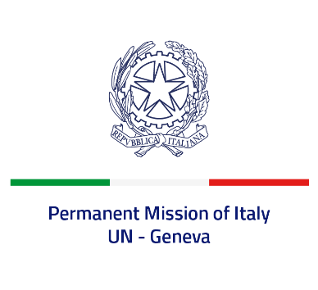
Check against delivery
UPR 36 - Panama
Tuesday 3 November 2020, 14:30 - 18:00

Delivered by: Ambassador Gian Lorenzo Cornado, Permanent Representative of Italy

(Focal point: Angela Zanca, First Secretary)

Thank you, Madam President.

We welcome the distinguished members of the delegation of Panama and thank them for their national report and today’s presentation.

Italy noted with appreciation steps taken by Panama since the second UPR cycle in order to implement the recommendations received.

We consider favorably the adoption of legislation and national policies as mentioned in Panama’s national report to prevent discrimination against persons belonging to vulnerable groups and violence against children and adolescents, to promote gender equality and to assist women victims of violence as well as trafficking victims, while stressing the importance of concrete and effective implementation.

Madam President,
Italy seizes this opportunity to offer Panama the following recommendations:

- Fully protect children rights, including by preventing child, early and forced marriages and by rising the age of criminal responsibility;
- Fully implement the 7/2018 law aiming at combating any form of discrimination, including against women, children and LGBTI persons;
- Increase the efforts to ensure that the rights of indigenous persons are protected and that they have access to basic services;
- Concretely align the national legislation to international standards by recognizing the competences of the human rights treaty bodies to consider individual complaints.

We wish Panama a successful review.
I thank you.

