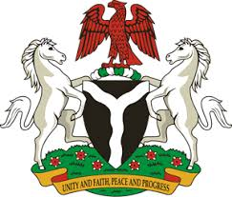
Please check against delivery
HUMAN RIGHTS COUNCIL
36TH SESSION OF THE WORKING GROUP OF THE UPR
REVIEW OF CROATIA
10TH NOVEMBER, 2020
STATEMENT BY NIGERIA
Madam President,
Nigeria welcomes the delegation of the Republic of Croatia, and thanks it for the presentation of the country’s National Report for the Third Cycle of the UPR. We commend the Government of Croatia for its continued cooperation and engagement with the UPR process and other human rights mechanisms.
2. Nigeria takes positive note of Croatia’s efforts in combatting hate speech and hate crimes, as well as measures adopted to ensure non-discrimination. We also commend the Government’s efforts in the promotion and protection of the rights of migrants, and persons in vulnerable situations.
3. In the spirit of constructive dialogue, Nigeria makes the following recommendations to Croatia:
- Continue efforts in combatting hate speech and hate crimes, as well as the protection of the rights of migrants; and
- Adopt further anti-discrimination measures, with a view to ensure the full enjoyment of human rights by all.
4. Finally, we wish Croatia every success in its review process.
I thank you.
******

