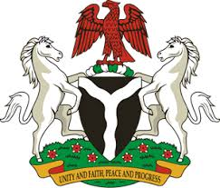
Please check against delivery
HUMAN RIGHTS COUNCIL
36TH SESSION OF THE WORKING GROUP OF THE UPR
REVIEW OF JAMAICA
11TH NOVEMBER, 2020
STATEMENT BY NIGERIA
Madam President,
Nigeria warmly welcomes the delegation of Jamaica to the presentation of the country’s National Report for the Third Cycle UPR, and thanks it for the update provided today. We commend the Government of Jamaica for its efforts in implementing previous recommendations, and its continued cooperation and engagement with the UPR process, and other human rights mechanism.
2. Nigeria takes positive note of measures adopted by the Government of Jamaica, with a view to combatting gender-based violence, ensuring poverty reduction, as well as addressing the effect of climate change. We also commend the Government for its efforts in combatting human trafficking, and ensuring the rights to adequate standard of living.
3. While recognising the various efforts by the Government of Jamaica in upholding human rights, and in the spirit of constructive dialogue, Nigeria makes the following recommendations for the consideration of Jamaica:
- Continue efforts in ensuring poverty reduction, adequate standard of living, and the protection of the rights of persons in vulnerable situations; and
- Continue to adopt necessary measures to address the effect of climate change.
4. Finally, we wish Jamaica a very successful review process.
I thank you.
******

