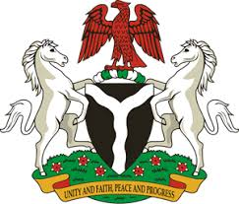
Please check against delivery
HUMAN RIGHTS COUNCIL
36TH SESSION OF THE WORKING GROUP OF THE UPR
REVIEW OF LIBYA
11TH NOVEMBER, 2020
STATEMENT BY NIGERIA
Madam President,
Nigeria warmly welcomes the delegation of Libya and thanks it for the presentation of the country’s Third Cycle UPR National Report. We commend the Government of Libya for its efforts in implementing the previous recommendations, and its continued cooperation and engagement with the UPR process.
2. While acknowledging the need for further improvement by the Government in the field of human rights, and in the spirit of constructive engagement, Nigeria makes the following recommendations to Libya:
- Adopt further measures in combatting human trafficking, and ensure the protection of the rights of victims of trafficking, as well as the rights of migrants;
- Sustain efforts at national reconciliation, and seek necessary international support to enhance its capacity to protect human rights.
3. Nigeria takes positive note of Libya efforts towards women empowerment and the protection of their rights. We also commend the Government for measures adopted to ensure access to education and health, and note with encouragement the Government efforts at national reconciliation.
4. In conclusion, we wish Libya a very successful review process.
I thank you.
******

