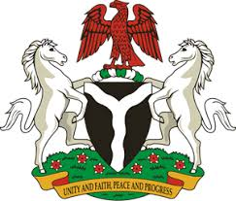

Please check against delivery
HUMAN RIGHTS COUNCIL
36TH SESSION OF THE WORKING GROUP OF THE UPR
REVIEW OF THE UNITED STATES OF AMERICA
9TH NOVEMBER, 2020
STATEMENT BY NIGERIA
Madam President,
Nigeria welcomes the delegation of the United States of America, and thanks it for the presentation of the country’s Third Cycle UPR National Report. We commend the Government of the United States of America for its continued cooperation and commitment to the UPR process.
2. In the spirit of constructive engagement, Nigeria recommends the following for the consideration of the United States of America:
- Continue efforts in combatting human trafficking, and ensure the protection of the rights of victims of trafficking, as well as the rights of migrants; and
- Adopt further measures to ensure the enjoyment of human rights by all without discrimination.
3. We wish the United States of America a very successful review process.
I thank you.
******

