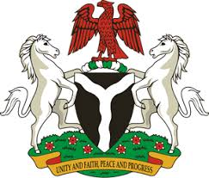
Please check against delivery
HUMAN RIGHTS COUNCIL
36TH SESSION OF THE WORKING GROUP OF THE UPR
REVIEW OF HONDURAS
5TH NOVEMBER, 2020
STATEMENT BY NIGERIA
Mr. Vice President,
Nigeria welcomes the delegation of the Republic of Honduras and thanks it for the presentation of the country’s National Report for the Third Cycle UPR. We commend the Government of Honduras for its efforts in implementing previous recommendations, and its continued cooperation and engagement with the UPR process, and other human rights mechanisms.
2. Nigeria takes positive note of measures adopted by the Government of Honduras in the protection of the rights of migrants and persons in vulnerable situations. The Government’s efforts in promoting economic growth, and ensuring social protection are also commendable.
3. While recognising the various efforts by the Government of Honduras in upholding human rights, Nigeria makes the following recommendations for the consideration of Honduras:
- Continue efforts in the protection of the rights of migrants, and persons in vulnerable situations; and
- Strengthen measures for the promotion and protection of human rights, and seek necessary support in this regard.
4. Finally, we wish Honduras a very successful review process.
I thank you.
******

