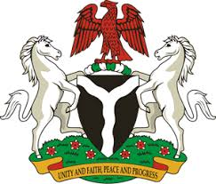
Please check against delivery
HUMAN RIGHTS COUNCIL
36TH SESSION OF THE WORKING GROUP OF THE UPR
REVIEW OF BULGARIA
6TH NOVEMBER, 2020
STATEMENT BY NIGERIA
Madam President,
Nigeria welcomes the delegation of the Republic of Bulgaria to the presentation of the country’s National Report for the Third Cycle of the UPR, and thanks it for the update provided today. We commend the Government of Bulgaria for its commitment to the UPR process and other human rights mechanisms, as well as efforts to implement the previous recommendations.
2. Nigeria applaud the Government of Bulgaria for its efforts in combatting human trafficking, and protecting the rights of victims, as well as countering corruption and organised crimes. We take positive note of Bulgaria’s efforts in fighting racism, hate speech and hate crimes.
3. In the spirit of constructive engagement, Nigeria makes the following recommendations for the consideration of Bulgaria:
- Scale up efforts in combatting racism, racial discrimination and hate crimes; and
- Adopt further measures in combatting human trafficking, and protecting the rights of victims, as well as the rights of migrants.
4. Finally, we wish Bulgaria a very successful review process.
I thank you.
******

