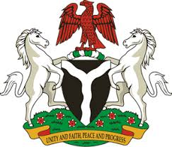
Please check against delivery
HUMAN RIGHTS COUNCIL
36TH SESSION OF THE WORKING GROUP OF THE UPR
REVIEW OF MALDIVES
4TH NOVEMBER, 2020
STATEMENT BY NIGERIA
Madam Vice President,
Nigeria welcomes the delegation of the Republic of Maldives to the presentation of the country’s Third Cycle UPR National Report. We commend the Government of Maldives for its commitment to the UPR process, and its efforts in implementing recommendations it accepted during the previous review.
2. Nigeria takes positive note of efforts by the Government of Maldives towards judicial and justice sector reform, as well as the empowerment of women. We commend the Government for measure being adopted, with a view to combatting human trafficking, and protecting the rights of victims, as well as the rights of migrants.
3. In the spirit of constructive dialogue, Nigeria recommends the following to Maldives:
- Scale up efforts in combatting human trafficking, and protecting the rights of victims, as well as the promotion and protection of the rights of migrants; and
- Continue efforts in ensuring access to justice, and the protection of the rights of persons in vulnerable situations.
4. In conclusion, we wish Maldives a very successful review process.
I thank you.
******

