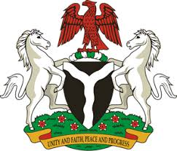
Please check against delivery
HUMAN RIGHTS COUNCIL
36TH SESSION OF THE WORKING GROUP OF THE UPR
REVIEW OF MALAWI
3RD NOVEMBER, 2020
STATEMENT BY NIGERIA
Madam Vice President,
Nigeria welcomes the delegation of the Republic of Malawi to the presentation of the country’s National Report for the Third Cycle UPR. We take positive note of efforts by the Government of Malawi towards the implementation of previous recommendations, as well as its commitment to the UPR process.
2. Nigeria notes with encouragement Malawi’s efforts at strengthening its legal and institutional frameworks for the promotion and protection of human rights. We commend the Government of Malawi for its determination to combat child trafficking and child labour, as well as efforts to ensure women empowerment. We also commend the Government’s efforts, with a view to protecting the rights of persons in vulnerable situations.
3. While acknowledging efforts by Malawi in upholding human rights and in the spirit of constructive engagement, Nigeria recommends the following to Malawi:
- Scale up efforts in ensuring the protection of the rights of children, by vigorously combatting child trafficking and child labour; and
- Sustain efforts in upholding human rights and seek necessary support to enhance its capacity in this regard.
4. In conclusion, we wish Malawi every success in its review process.
I thank you.
******

