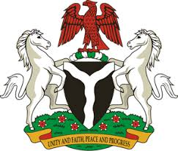
Please check against delivery
HUMAN RIGHTS COUNCIL
36TH SESSION OF THE WORKING GROUP OF THE UPR
REVIEW OF LIBERIA
2ND NOVEMBER, 2020
STATEMENT BY NIGERIA
Madam President,
Nigeria warmly welcomes the delegation of the Republic of Liberia and thanks it for the presentation of the country’s Third Cycle UPR National Report. We commend the Government of Liberia for its efforts in implementing the previous recommendations, and its continued cooperation and engagement with the UPR process.
2. Nigeria takes positive note of Liberia’s efforts in strengthening its legal and institutional frameworks for the promotion and protection of human rights. We commend the Government’s efforts in combatting sexual and gender-based violence, and encourages it to redouble efforts in this regard. We also note with encouragement Liberia efforts in the field of education, and upholding children’s rights.
3. While acknowledging the need for further improvement, and in the spirit of constructive engagement, Nigeria makes the following recommendations to Liberia:
- Sustain efforts in combatting sexual and gender-based violence, and ensure the empowerment of women, as well as ensure adequate standard of living; and
- Continue to mobilise resources and seek necessary support to enhance its capacity to protect and promote human rights and fundamental freedoms.
4. In conclusion, we wish Liberia a very successful review process.
I thank you.
******

