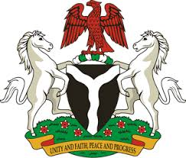
Please check against delivery
HUMAN RIGHTS COUNCIL
36TH SESSION OF THE WORKING GROUP OF THE UPR
REVIEW OF BELARUS
2ND NOVEMBER, 2020
STATEMENT BY NIGERIA
Madam President,
Nigeria welcomes the delegation of the Republic of Belarus and thanks it for the presentation of the country’s National Report for the Third Cycle UPR. We commend the Government of Belarus for its continued cooperation and engagement with the UPR process and other human rights mechanisms.
2. Nigeria takes positive note of the Government’s efforts to combat trafficking in persons and the protection of the rights of victims of human trafficking, as well as the rights of migrants. We also note with appreciation, steps being taken by the Government for the achievement of the Sustainable Development Goals.
3. In the spirit of constructive engagement, Nigeria makes the following recommendations for the consideration of Belarus:
- Adopt further measures in combatting trafficking in persons, and ensure the protection of the rights of victims, as well as the rights of migrants; and
- Continue efforts in ensuring the full enjoyment of human rights and fundamental freedoms by all its citizens.
4. Finally, we wish Belarus a very successful review process.
I thank you.
******

