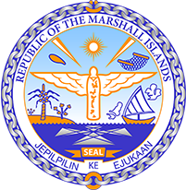

Republic of the Marshall Islands
STATEMENT by Samuel K. Jr. Lanwi, Deputy Permanent Representative
36th Session, Universal Periodic Review of Honduras
05 November 2020
Geneva

Check against delivery

Thank you, Madam/Mr. (Vice) President.
The Republic of the Marshall Islands welcomes the UPR report of Honduras. We particularly noted the efforts made to reinforce judicial resources to uphold human rights.
We commend the inclusiveness in the strategy for local social transformation, as well as the efforts on women, children, and indigenous rights.
Yet, we urge Honduras to do more to protect human rights and environmental defenders. They continue to face high levels of violence, intimidation, and judicial proceedings. These actors play an invaluable role in helping Honduras uphold its human rights obligations and combat climate change.
With these in mind and in the spirit of constructive engagement, we offer the following recommendations for consideration by Honduras:
- Ratify the Optional Protocol to the convention on the Elimination of All Forms of Discrimination against Women
- Ratify the International Labor Organization Domestic Workers Convention
- Develop and adopt legislation to combat discrimination against vulnerable groups
- Adopt a national plan of action to implement the United Nations Guiding Principles on Business and Human Rights
- Pass legislation regulating sex work to limit or prevent the ill-treatment and discrimination of sex workers
In closing, we wish Honduras every success during this review and implementation of all accepted recommendations.
Kommol tata and thank you.

