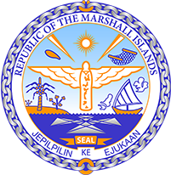

Republic of the Marshall Islands
STATEMENT by Samuel K. Jr. Lanwi, Deputy Permanent Representative
36th Session, Universal Periodic Review
11 November 2020
Geneva
Interactive Dialogue: JAMAICA

Check against delivery

Thank you, Madam/Mr. (Vice) President.
The Republic of the Marshall Islands welcomes the esteemed delegation of Jamaica to the 3rd cycle of the UPR and thank them for their national report. We note the commendable progress that Jamaica has undertaken towards its human rights obligations at all levels since its last review.
We welcome Jamaica’s ongoing efforts to further build upon this progress as evident through numerous initiatives that commenced during the reporting period.
These include the publication of a Gender Mainstreaming Manual in 2016 and the establishment of a Gender Advisory Council in 2018 along with guidelines that have improved gender balance in public leadership and an action plan on gender-based violence, among others.
Having said that, as a fellow SIDS, we also urge Jamaica to continue to step up and expand its efforts in addressing environmental matters at all levels.
In a constructive spirit, we recommend the following for Jamaica’s consideration:
1. Ratify the Escazu Agreement;
2. Ratify remaining UN human rights treaties;
3. Ratify the Rome Statute of the International Criminal Court;
4. Continue to expand efforts to reduce poverty, particularly among rural populations.
We wish the delegation of Jamaica a very successful review during this third UPR cycle.
Kommol tata and thank you.

