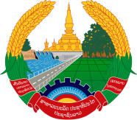
Statement by the Representative of the Lao PDR
At the 36th Session of UPR Working Group
Geneva, 2-13 November 2020

Review of Mongolia: 4 November 2020

Madam President,
Laos warmly welcomes the distinguished delegation of Mongolia to the UPR session and thanks for its comprehensive report presented today.

Laos would like to commend the progress made by the Government of Mongolia in implementing the adopted recommendations from the previous cycle of UPR as well as its commitment to further promote and protect human rights, including the rights of children, women, people with disabilities and elderly persons in the country with national policies and programmes.

In constructive spirit, Laos wishes to make two recommendations as follows:

- Continue its efforts to improve the protection of the rights and interests of vulnerable populations such as children, women, people with disabilities and elderly persons ; and

- Continue its efforts to promote gender equality as well as to enhance participation of women in decision making through “the National Programme of Gender Equality”.

We wish Mongolia every success in the review.

I thank you, Madam President.

