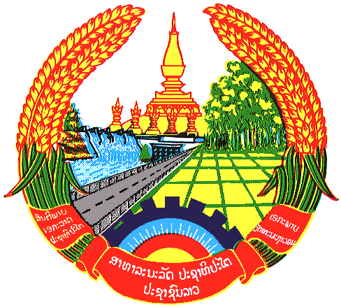
Statement by the Representative of the Lao PDR
At the 36th Session of UPR Working Group
Geneva, 2-13 November 2020
Review of Bulgaria: 6 November 2020
Madam President,
The Lao PDR warmly welcomes the distinguished delegation of Bulgaria to the UPR session and thanks for its comprehensive report.
Laos commends Bulgaria on the progress made in implementing the adopted recommendations from the previous cycle of UPR and the achievement made in the development of human rights in the country, including gender equality, rights of the child and rights of persons with disabilities through its national strategies.
In this respect, Laos wishes to recommend as follows:
- Continues to promote gender equality, including rural development policies; and
- Continues to improve the quality of life of children through the development of education, health and social services system in accordance with the principle of guarantee equal access to all children, including children with disabilities.
We wish Bulgaria a very successful UPR.
I thank you, Madam President.

