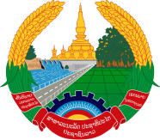
Statement by the Representative of the Lao PDR
At the 36th Session of UPR Working Group
Geneva, 2-13 November 2020

Review of Belarus: 2 November 2020

Madam President,
The Lao PDR warmly welcomes the distinguished delegation of Belarus to the UPR session and thanks for its comprehensive report presented today.

Laos would like to commend the Government of Belarus on the progress made in the implementation of the adopted recommendations from the previous cycle of UPR as well as the achievement made in promotion and protection of human rights in the country, namely rights to education and rights of women, children, persons with disabilities through UN human rights mechanisms, especially the UPR.

In constructive spirit, Laos wishes to recommend as follows:

- Continue its efforts to implement the Demographic Development Outreach Plan in order to raise public awareness on demographic development issues and advocate for traditional family values; and
- Continue its conceptual framework for the development of education system, looking ahead to 2030.

We wish Belarus very success of its UPR.

I thank you, Madam President.

