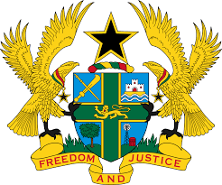

STATEMENT BY GHANA DELIVERED BY H.E RAMSES JOSEPH CLELAND,
AMBASSADOR AND PERMANENT REPRESENTATIVE, MONDAY 9TH NOVEMBER, 2020

REVIEW OF UNITED STATES OF AMERICA

Thank you Madam President,
Ghana welcomes the delegation of the US to the UPR Working Group.
We commend the progress made by the US in implementing a number of recommendations it accepted during the second Cycle of the UPR. We further note the efforts made to safeguard and protect women and girls through the introduction of the Strategy on women, Peace and security in June, 2019.
My delegation is however concerned with the several Executive Orders and programmes designed to restrict immigration in the country.
Ghana recommends the following to the US:
- Continue with the on-going efforts to ratify outstanding core international Human Rights Instruments at the earliest convenience;

- Take steps to ensure the full implementation of domestic and international laws to end all forms of discrimination including discrimination against race, sex, religion and bring the perpetrators to book;

- Improve conditions of confinement pertaining to immigrants to meet human rights standards and International treaties.

We wish US every success with the review process.
I thank you.

