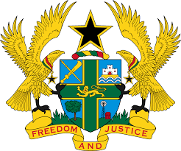

STATEMENT BY GHANA DELIVERED BY H.E RAMSES JOSEPH CLELAND,
AMBASSADOR AND PERMANENT REPRESENTATIVE, TUESDAY 3RD NOVEMBER 2020

REVIEW OF MALAWI

Thank you, Mr. President
We warmly welcome the delegation of Malawi to the UPR Working Group.
Ghana acknowledges the significant progress made by Malawi in ratifying and amending key legislation in the promotion and protection of human rights which includes Access to Information Act, 2017 and Political Parties Act, 2018.
We further commend the government for its efforts to eradicate child labour, which led to the adoption of the first National Action Plan on Child Labour Elimination (2012-2017).
In the spirt of constructive dialogue Ghana has the following recommendations:
- Continue to reinforce relevant measures to ensure the protection of the vulnerable population, including women, children, persons accused of witchcraft, persons with disabilities and albinos;
- Consider ratifying outstanding International instruments; of note are the Optional Protocol to the Convention on the Elimination of All Forms of Discrimination against Women (CEDAW) and the Optional Protocol to the Convention against Torture and Other Cruel, Inhuman or Degrading Treatment or Punishment (OP-CAT).

Ghana wishes Malawi a successful review outcome.

I thank you.

