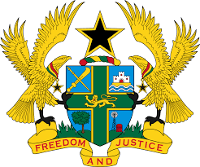

STATEMENT BY GHANA DELIVERED BY H.E RAMSES JOSEPH CLELAND, AMBASSADOR AND PERMANENT REPRESENTATIVE,
WEDNESDAY 11TH NOVEMBER 2020

REVIEW OF LIBYA

Thank you, Madam President.
Ghana extends a warm welcome to the delegation of Libya to the UPR Working Group.
My delegation notes the efforts made Libya to implement the accepted recommendations during its last UPR review. We further note the negotiations that ended in the adoption of the Declaration or Agreement of Skhirat and initiatives undertaken to ensure the protection and promotion of its population.
In the spirit of constructive dialogue Ghana has the following recommendations:
- Ensure gender equality by protecting and promoting the rights of women, including amending domestic law especially those that discriminate against Libyan women married to foreign nationals;
- Continue efforts to ensure the ratification of outstanding International treaties and protocols, including the Optional Protocol to the Convention against Torture and Other Cruel, Inhuman or Degrading Treatment or Punishment at the earliest convenience (OP-CAT) and finally;
- To continue ongoing efforts to investigate, prosecute and punish perpetrators of war crimes and other human rights violations.
Ghana wishes Libya a successful review outcome.

I thank you.

