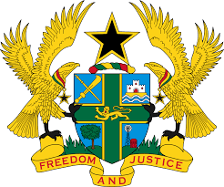

STATEMENT BY GHANA DELIVERED BY H.E RAMSES JOSEPH CLELAND,
AMBASSADOR AND PERMANENT REPRESENTATIVE, MONDAY 2ND NOVEMBER, 2020

REVIEW OF LIBERIA

Thank you, Mr. President,
Ghana extends a warm welcome to the distinguished delegation of Liberia to the UPR Working Group.
We commend the progress made by Liberia in the last couple of years to promote and protect human rights and fundamental freedoms. We take note of the establishment of the UN OHCHR Office in Liberia as well as the notable achievements in the area of constitutional reforms. We further commend the Government for measures undertaken to eliminate discrimination against Ebola Survivors.
To further expand the democratic frontiers of Liberia, Ghana wishes to make the following three recommendations:
- Continue with the ongoing efforts in the implementation of both International and domestic legislations aimed at protecting human rights and gender based violence;
- Continue with the ongoing constitutional reforms in line with international best practices and obligations and, finally;
- Consider ratifying outstanding International treaties and conventions, which include the Optional Protocol to the Convention on the Elimination of All Forms of Discrimination against Women at the earliest convenience.
Ghana wishes Liberia every success with the review process.

I thank you.

