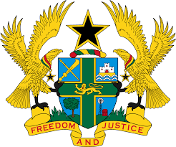
,

STATEMENT BY GHANA DELIVERED BY H.E RAMSES JOSEPH CLELAND, AMBASSADOR AND PERMANENT REPRESENTATIVE,
WEDNESDAY, 11TH NOVEMBER 2020

REVIEW OF JAMAICA

Thank you, Madam President.
Ghana warmly welcomes the delegation of Jamaica to the UPR Working Group.
We commend the steps taken by the Government since their last UPR to promote and protect human rights in the country, including the adoption and implementation of the National Strategic Action Plan to Eliminate Gender-based Violence from 2017-2027 as well as the commencement of the implementation of the National Poverty Reduction Programme 2018.
We also note the ratification of the Convention on Decent Work for Domestic Workers in 2016.
To further strengthen human rights promotion and protection in Jamaica my delegation wishes to make the following three recommendations:

- Continue its efforts to promptly accede to the International Convention against Torture and Other Cruel, Inhuman or Degrading Treatment or Punishment and its Optional Protocol;
- Intensify its efforts to combat crime, violence and human trafficking and address its high global rate on homicide and lastly;
- Continue its efforts to strengthen measures to foster training and awareness of public officials, including the security forces on relevant human rights issues.
My delegation wishes Jamaica every success with the UPR.
I thank you.

