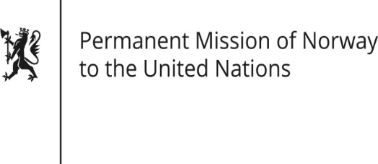

STATEMENT

HRC/WG on the Universal Periodic Review 36th session
Norway's statement during the 36th UPR session of the Human Rights Council on the human rights situation in Honduras
as delivered by Ambassador Tine Mørch Smith,
Permanent Representative of Norway

5 November 2020

Check against delivery

Madam President,

Norway welcomes the participation of Honduras in the UPR process. [In particular, we welcome the establishment of an OHCHR country office, the adoption of the Law on Protection of Human Rights Defenders, Journalists, Communicators and Operators of Justice, and the establishment of the National Protection Mechanism.]

The situation of human rights defenders and other vulnerable groups gives cause for concern. We are also concerned about the role of the military in law enforcement, and about restrictions on freedom of expression and peaceful assembly in the criminal code.

Norway recommends that Honduras:

1) refrains from criminalising human rights defenders and ensures their protection;

2) ensures that crimes against human rights defenders, journalists, LGBTI people, indigenous people and Afro-Honduran activists, are properly investigated, and that those responsible are held accountable;

3) revises ambiguous language in the penal code in line with rule of law principles;

4) ensures that law enforcement is carried out exclusively by civilian police forces.

Thank you.

