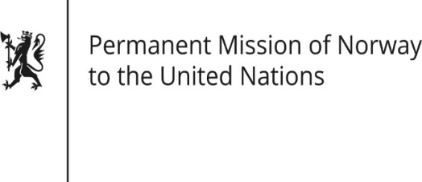

STATEMENT

HRC/WG on the Universal Periodic Review 36th session
Norway's statement during the 36th UPR session of the Human Rights Council on the human rights situation in Malawi
as delivered by Ambassador Tine Mørch Smith,
Permanent Representative of Norway

3 November 2020

Check against delivery

Madam President,

Norway commends Malawi for the process leading to the peaceful transition of power in 2020, [which demonstrated the integrity of key institutions and adherence to the principles of the rule of law]. While many countries have seen a weakening of democratic accountability and respect for human rights during the COVID-19 pandemic, Malawi has instead seen an improvement.

Norway recommends that Malawi:

1) implements national legislation [and policies] to safeguard women's rights to sexual and reproductive health services and information, and to end child marriage;

2) takes all necessary steps to bring justice to victims of sexual and gender-based violence, [to allocate resources for the implementation of national policies and action plans,] and [in particular to] ensure that the cases of rape and sexual assault on women in Msundwe are properly investigated;

3) harmonises national legislation with ratified conventions relating to modern slavery, [takes steps to] abolish the tenancy labour system, and establishes an effective system for monitoring workplace compliance with national labour laws;

4) decriminalises same-sex relationships and repeals legislation that discriminates against LGBTI people.

Thank you.

