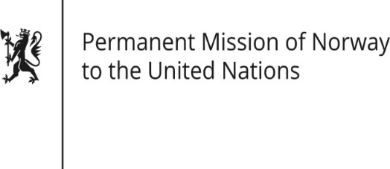

STATEMENT

HRC/WG on the Universal Periodic Review 36th session
Norway's statement during the 36th UPR session of the Human Rights Council on the human rights situation in Libya
as delivered by Ambassador Tine Mørch Smith,
Permanent Representative of Norway
11 November 2020

Check against delivery

Madam President,

Norway welcomes Libya’s participation in the UPR process, but notes with regret that the human rights situation has deteriorated since the last review.

Norway recommends that Libya:

1) cooperates fully with the Independent Fact-Finding Mission on Libya established by the Human Rights Council, as well as with the International Criminal Court;

2) ensures women’s [access to and] participation in political, constitutional and transitional justice processes;

3) protects journalists, media workers and human rights defenders from acts of violence and harassment, investigate attacks against them and holds the perpetrators accountable.

4) ensures the unconditional release of people who have been arbitrarily detained or otherwise unlawfully deprived of their liberty, investigates all allegations of torture, summary executions, enforced disappearances and other abuses, and holds the perpetrators accountable.

Thank you.

