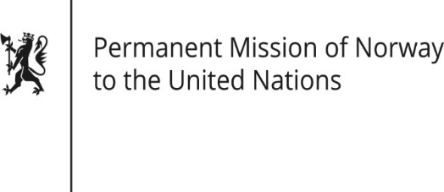

STATEMENT

HRC/WG on the Universal Periodic Review 36th session
Norway's statement during the 36th UPR session of the Human Rights Council on the human rights situation in Mongolia
as delivered by Ambassador Tine Mørch Smith,
Permanent Representative of Norway

4 November 2020

Check against delivery

Madam President,

Norway welcomes Mongolia’s participation in the UPR process. We commend Mongolia’s efforts to create a legal framework and human rights culture that promotes equality and security for all.

Norway remains concerned about conditions for children, women and people with disabilities in some sectors, including education establishments. [While we recognise that relevant legislation and national programmes have been introduced, it is clear that implementation continues to be a challenge.]

Norway recommends that Mongolia:

1) adopts measures to ensure social inclusion of children with disabilities and to increase the participation of women with disabilities in decision-making processes that affect them;

2) takes further steps to ensure that children are protected from all forms of violence and exploitation, and in particular from child labour.

3) adopts further measures to improve living conditions in prisons and strengthen the independent and regular monitoring of all places of deprivation of liberty.

Thank you.

