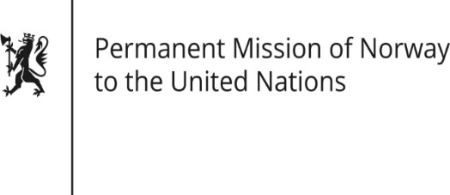

STATEMENT

HRC/WG on the Universal Periodic Review 36th session
Norway's statement during the 36th UPR session of the Human Rights Council on the human rights situation in Croatia
as delivered by First Secretary Mr. Sean Lobo,
Permanent Representative of Norway

10 November 2020

Check against delivery

Madam President,

Norway welcomes Croatia’s participation in the UPR process and notes the positive steps taken since the last review.

However, Norway notes that further progress is needed in some areas.

Norway recommends that Croatia:

1) further strengthens its efforts to ensure that criminal, civil and administrative legislation is brought in line with ECRI’s General Policy Recommendation No. 7 on national legislation to combat intolerance, hate speech, racism and racial discrimination.

2) strengthens the freedom of the media, intensifies efforts to investigate threats against journalists and media workers, and protects local media outlets and journalists against arbitrary lawsuits.

3) continues its work to strengthen the judicial system, in particular to promote the independence and efficiency of the judicial system in accordance with the European Commission's 2020 Rule of Law Report 2020.

4) Continue to prioritize the fight against corruption, including at the highest level of government [in line with the report of the Council of Europe's Group of States against Corruption (GRECO)].

Thank you.

