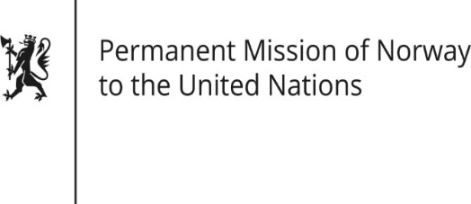

STATEMENT

HRC/WG on the Universal Periodic Review 36th session
Norway's statement during the 36th UPR session of the Human Rights Council on the human rights situation in United States of America
as delivered by Ambassador Tine Mørch Smith,
Permanent Representative of Norway

9 November 2020

Check against delivery

Madam President,

Norway welcomes the participation of the United States in the UPR process and notes the positive steps taken since the last review.

Norway remains concerned about the use of the death penalty in the United States, [and the resumption of federal executions after a 17-year hiatus].

Norway is concerned about the excessive use of force by the police.

Norway recommends that the United States:

1) repeals the decision to resume federal capital punishment and takes steps to promote federal and state-level moratoriums on executions with a view to permanently abolishing the death penalty;

2) increases action to prevent excessive use of force by law enforcement officers, and ensures that relevant allegations are investigated and that perpetrators are prosecuted.

3) lifts funding restrictions on United States foreign assistance to promote women’s full access to sexual and reproductive health and rights.

4) ensures that detention conditions for immigrants, particularly for minors, comply with international human rights law.

Thank you.

