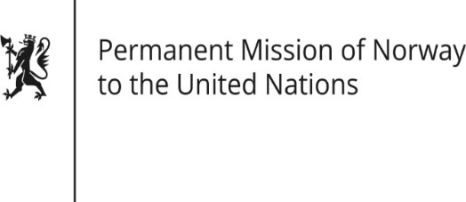

STATEMENT

HRC/WG on the Universal Periodic Review 36th session
Norway's statement during the 36th UPR session of the Human Rights Council on the human rights situation in

the Republic of Belarus
as delivered by Ambassador Tine Mørch Smith,
Permanent Representative of Norway

2 November 2020

Check against delivery
Madam President,

[Norway welcomes the participation of Belarus in the UPR process.]

Norway deeply regrets that the Government of Belarus has made little effort to end the systemic denial of human rights to its citizens, [and that the situation has further deteriorated in recent months].

Norway recommends that the Belarusian Government:

- immediately halts the violent repression of peaceful demonstrations and respects the legitimate right of the people of Belarus to participate in public life;
- initiates an open and inclusive dialogue with representatives of civil society, academia and the general public, aimed at ensuring the right of the people of Belarus to free and fair elections;
- ensures the unconditional release of people who have been arbitrarily detained or otherwise unlawfully deprived of their liberty, including members of the opposition, human rights defenders, journalists, media workers, civil society activists, and political prisoners, and ensures access to justice [including an effective remedy in cases of documented human rights violations];
- takes the necessary action to ensure freedom of expression, and in particular to ensure media independence and unfettered access to the internet;
- takes steps to abolish the death penalty under all circumstances.
Thank you.

