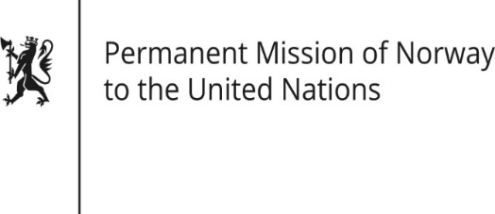

STATEMENT

HRC/WG on the Universal Periodic Review 36th session
Norway's statement during the 36th UPR session of the Human Rights Council on the human rights situation in Bulgaria
as delivered by Advisor Lena Eskeland,
Permanent Representative of Norway

6 November 2020

Check against delivery

Madam President,

Norway welcomes Bulgaria’s participation in the UPR process, and notes the progress that has been made since the last review, such as the signing or ratification of a number of protocols. Norway remains concerned about the number of Roma children who drop out of school.

Norway recommends that Bulgaria:

- implements measures to ensure a safe and independent working environment for journalists and media workers, and intensifies efforts to diversity ownership of the media and promote public media independence;
- fosters the development of diverse, vibrant and engaged civil society organisations;
- ratifies the Istanbul Convention and strengthens its efforts to combat domestic violence;
- actively denounces, and increases action to prevent, racist, homophobic and xenophobic rhetoric in the public sphere, including against Roma and LGBTI-people.

Thank you.

