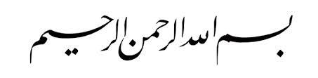

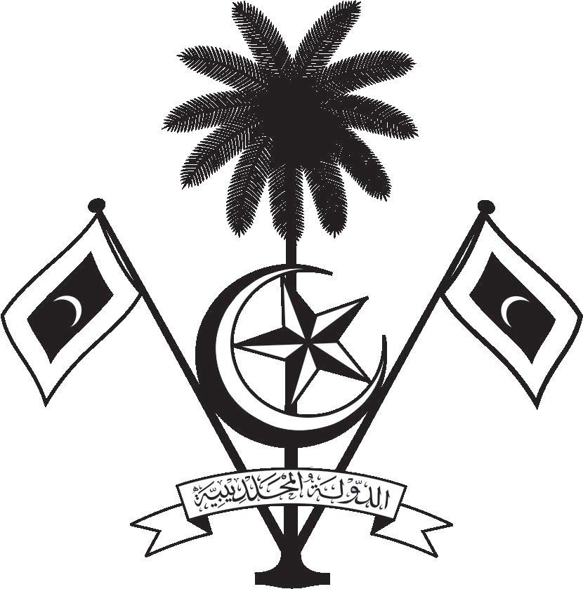

އ.ދ.ގެ ޖެނީވާ އޮފީހާއި ޖެނީވާގައި ހުންނަ ބައިނަލްއަޤްވާމީ ޖަމިއްޔާތަކަށް ކަނޑައަޅާފައިވާ ދިވެހިރާއްޖޭގެ ދާއިމީ މިޝަން
PERMANENT MISSION OF THE REPUBLIC OF MALDIVES TO THE UNITED NATIONS OFFICE
AND OTHER INTERNATIONAL ORGANISATIONS AT GENEVA

36th Session of the Working Group of the Universal Periodic Review
2-14 November 2020, Geneva
Review of United States of America
9 November 2020
Statement by:
Dr Asim Ahmed| Permanent Representative
Check against delivery
Thank you, Madam President,

The Maldives extends a warm welcome to the high-level delegation of the United States of America to the UPR process and thank them for their presentation today.
In a constructive spirit of engagement, the Maldives presents the following 2 recommendations:

- While noting the leadership role of the US in championing human rights, we would like to encourage the US to actively re-engage with the Human Rights Council and Special Procedures Mechanism of the OHCHR.

- While recognizing the immense efforts undertaken by the US for the promotion and protection of the rights of women and children, we encourage to expedite the process of ratification of the Convention on the Elimination of All Forms of Discrimination against Women and the Convention on the Rights of the Child.

My delegation wishes the United States of America every success at this third cycle review.

Thank you, Madam. President.

