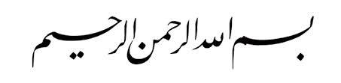

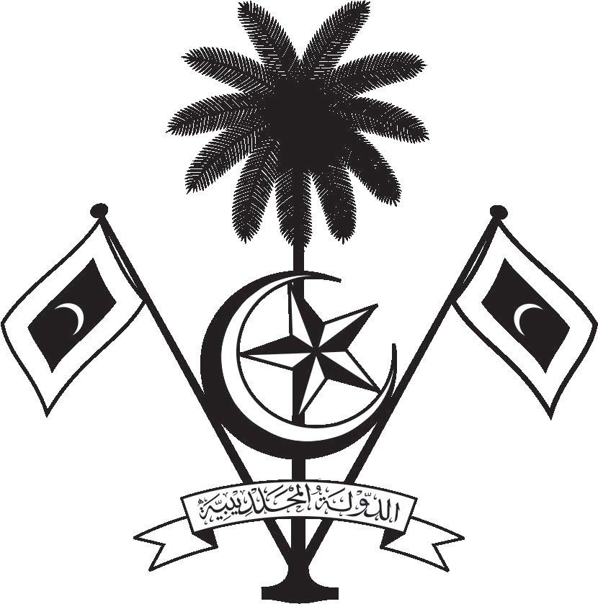

އ.ދ.ގެ ޖެނީވާ އޮފީހާއި ޖެނީވާގައި ހުންނަ ބައިނަލްއަޤްވާމީ ޖަމިއްޔާތަކަށް ކަނޑައަޅާފައިވާ ދިވެހިރާއްޖޭގެ ދާއިމީ މިޝަން
PERMANENT MISSION OF THE REPUBLIC OF MALDIVES TO THE UNITED NATIONS OFFICE
AND OTHER INTERNATIONAL ORGANISATIONS AT GENEVA

36th Session of the Working Group of the Universal Periodic Review
2-13 November 2020, Geneva
Review of Marshall Islands
9 November 2020
Statement by:

Check against delivery
Thank you, Madam. President,

The Maldives extends a warm welcome to the high-level delegation of Marshall Islands to this third cycle review and thank them for their presentation today.

The Maldives commends the Government of Marshall Islands for its commitment in addressing impacts of climate change through its efforts to implement adaptation and mitigation projects. We welcome the adoption of the Joint National Action Plan for Climate Change Adaptation and Disaster Risk Management. We also welcome the efforts of Marshall Islands in keeping up with its international commitments and ratifying ICCPR, ICESCR, CERD, CAT, 2 Optional Protocol of CRC and Optional Protocol of CEDAW.

In constructive spirit, the Maldives presents the following two recommendations to Marshall Islands:

1. To strengthen its efforts to ensure equal access to quality education especially for girls and children with disabilities.
2. To strengthen its efforts to implement birth registration procedures and issuance of birth certificates.

We wish our fellow Small Island Development State, Marshall Islands every success at this review.
Thank you, Mr. President.

