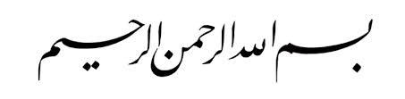

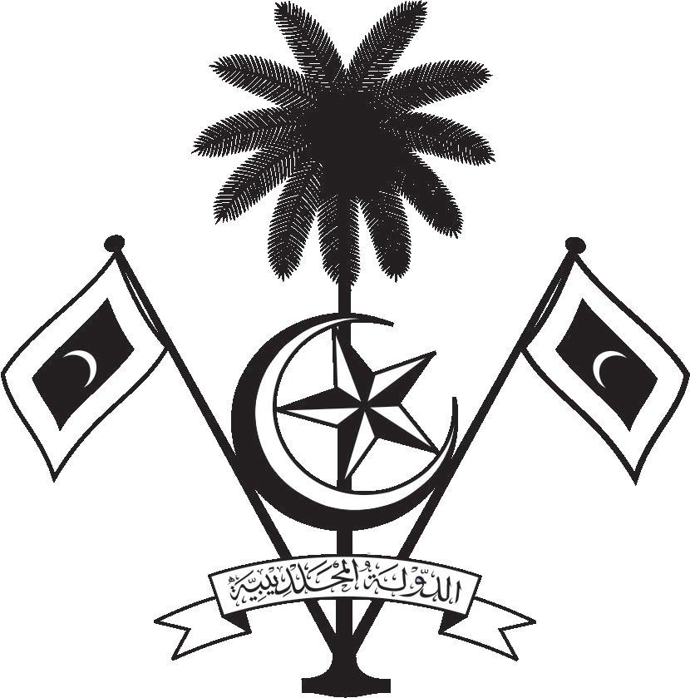

އ.ދ.ގެ ޖެނީވާ އޮފީހާއި ޖެނީވާގައި ހުންނަ ބައިނަލްއަޤްވާމީ ޖަމިއްޔާތަކަށް ކަނޑައަޅާފައިވާ ދިވެހިރާއްޖޭގެ ދާއިމީ މިޝަން
PERMANENT MISSION OF THE REPUBLIC OF MALDIVES TO THE UNITED NATIONS OFFICE
AND OTHER INTERNATIONAL ORGANISATIONS AT GENEVA

36th Session of the Working Group of the Universal Periodic Review
2-13 November 2020, Geneva
Review of Jamaica
11 November 2020
Statement by:
Ms Hawla Ahmed Didi| Deputy Permanent Representative

Check against delivery
Thank you, Excellency,

The Maldives extends a warm welcome to the high-level delegation of Jamaica to this third cycle review and thank them for their presentation today.

The Maldives is encouraged by Jamaica’s commitment to the climate change adaptation and mitigation agenda through the development of policy instruments and the implementation of these actions across the nation. We also commend the establishment of the National Task Force against Trafficking in Persons.

In constructive spirit, the Maldives presents the following two recommendations to Jamaica:

1. To strengthen its efforts to promote gender equality and equal participation in decision-making positions in public and political life.
2. To strengthen its efforts to ensure that all children complete their compulsory education and adopt a compulsory education policy for youth.

We wish our fellow Small Island Developing State, Jamaica every success at this review.
I thank you .

