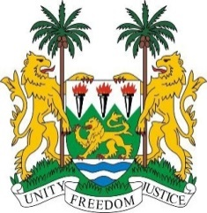
SIERRA LEONE
36th Session of the UPR (2 – 13 November 2020)

UPR Review of Maldives
4 November 2020 (14:30 – 18:00)

Madam President,
Sierra Leone thanks the delegation of Maldives for the presentation of its national report and for its engagement with the UPR process.
We recognise the impact that Covid-19 has had on Maldives, and we welcome the measures taken by the government to remedy the situation, including reprioritizing the existing Strategic Action Plan to adapt and determine socio-economic and governance policies for 2021-2022.
Further, Sierra Leone notes with appreciation Maldives’ efforts towards improving the rule of law, strengthening independent institutions, implementing decentralization, and building resilient communities.
Considering Maldives is one of the most vulnerable countries to the adverse impacts of climate change, we reiterate our call on the international community to assist Maldives efforts towards to implement pragmatic and feasible measures for climate resiliency.
In the spirit of constructive engagement Sierra Leone would like to recommend the following to Maldives:
- Expedite measures to implement the Gender Equality Law (18/2016) and the Domestic Violence Prevention Act 2012, and formalize the relevant policy measures with stakeholder consultations, for immediate implementation
- Accede to the International Convention on the Protection of the Rights of All Migrant Workers and Members of Their Families
- Substantively revise discriminatory legislations, particularly all provisions that discriminate on the basis of religion, and safeguard the rights to freedom of opinion and expression as required under international law
Sierra Leone wishes Maldives success with the implementation of the recommendations it receives during this third UPR cycle.
I thank you, Madam President

