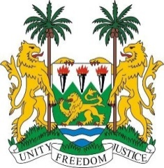
PERMANENT MISSION OF SIERRA LEONE TO
THE UNITED NATIONS IN GENEVA

36th Session of the Universal Periodic Review
(2nd – 13th NOVEMBER, 2020)

JAMAICA

11th November 2020

Madam President,

Sierra Leone warmly welcomes and thanks the delegation of Jamaica for the presentation of its national report and for its engagement with the UPR process.

My delegation commends the Government of Jamaica for establishing a National Human Rights Institution.

In the spirit of constructive engagement, Sierra Leone makes the following recommendations to the Government of Jamaica:

- We renew our call for a moratorium with a view to abolishing the death penalty.

- Consider ratifying the ICPPED and the Convention Against Torture.

- Address gender-based violence and all other forms of violence with a view to bringing perpetrators to justice.

- Take measures to decrease detention of children, migrants and reduce prison overcrowding.

Sierra Leone urges the Government of Jamaica to provide adequate funding to its National Human Rights Institution to guarantee its independence and freedom from government control in conformity with the Paris Principles.

My delegation notes that women, children and minorities are among vulnerable groups that require robust protective measures by the Government of Jamaica.

In conclusion, Sierra Leone wishes Jamaica every success in its 3rd cycle review.

Thank you, Madam President.

