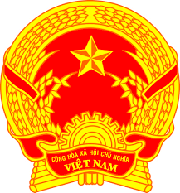
Statement of the Socialist Republic of Viet Nam
At the 36th Session of the UPR Working Group, Review of Mongolia
(Geneva, 04 November 2020, 9:00-12:30)
Delivered by Mr. Quang Binh LE, Permanent Mission of Viet Nam

Time: 01 minute 35 seconds
Madam President,
My delegation welcomes and thanks the Delegation of Mongolia for their presentation.
Viet Nam is appreciative of Mongolia’s commitment to uphold international human rights mechanisms and its active role as a first-time member of the Human Rights Council for the term 2016-2018.
We welcome Mongolia’s effective cooperation with the Office of the UN High Commissioner for Human Rights in developing the National Recommendations Tracking Database. We also take good note of their approval of the National Programme for the Elimination of the Worst Forms of Child Labour and the establishment of a national committee to implement the programme.
Viet Nam would like to recommend the following to Mongolia:
- Continue strengthening welfare and social programmes to improve the quality of life of the people, particularly the most marginalized.
- Continue the efforts in the protection of the rights of the child.
Finally, we wish the Government of Mongolia a successful review.
Thank you, Madam President./.

