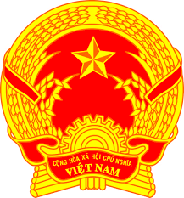
Statement of the Socialist Republic of Viet Nam
At the 36th Session of the UPR Working Group
Review of the Republic of Maldives
(Geneva, 04 November 2020, 14:30-18:00)
Delivered by Ms. NGUYEN Phuong Anh, Deputy Permanent Representative

Time: 01 minute 10 seconds

Madam President,
Viet Nam warmly welcomes the delegation of the Republic of Maldives to this UPR session.
We are encouraged by the Maldives making gender equality and inclusivity a cross cutting priority in the Government’s Strategic Action Plan 2013- 2023, especially in face of climate change and the Covid-19 pandemic.
In this context, Viet Nam would like to make two recommendations to the Maldives:
1. Further enhance awareness-raising activities on the impact of climate change on the full enjoyment of human rights.
2. Strengthen measures and programs aimed at promoting gender equality and facilitating the participation of women in all aspects of life in the country.
Finally, we wish the Maldives every success in this review cycle.
I thank you, Madam President./.

