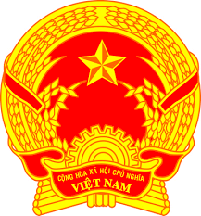
STATEMENT OF VIETNAM
At the Review of the UPR Report of Libya
(Thursday, 11 November 2020)

Madam President,
Viet Nam welcomes the delegation of Libya and thanks it for the presentation of the national report.
Viet Nam takes a good note of Libya’s commitment to implementing its pledges and to take an inclusive approach to promoting and protecting human rights although it is under a devastating war.
In a spirit of constructive dialogue, Viet Nam recommends Libya to:
1. Continue its efforts to promote peace and security in order to facilitate the enjoyment of human rights of its people;
2. Make efforts to publicize and realize the right to development.
Viet Nam wishes Libya a successful review.
Thank you, Madam President./.

