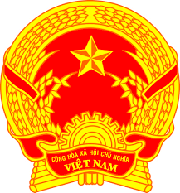
STATEMENT OF VIETNAM
At the Review of the UPR Report of Honduras
(Thursday, 5 November 2020)

Madam President,
Viet Nam welcomes the delegation of Honduras and thanks it for the presentation of the national report.
Viet Nam commends Honduras’s strong determination in the implementation of the Sustainable Development Goals (SDGs), which helps enhance human rights of its people. The measures taken by Honduras, such as the creation of the National Commission for the 2030 Agenda for Sustainable Development and the National SDGs Agenda could serve as best practices in realizing the 2030 Agenda. Viet Nam also welcomes Honduras’s initiatives in promoting gender equality, the rights of women, children and persons from other vulnerable groups.
In a spirit of constructive dialogue, Viet Nam recommends Honduras to:
1. Continue to strengthen its efforts in implementing SDGs for the better enjoyment of human rights of its people;
2. Continue its efforts to achieve gender equality and further promote the rights of women, children and persons from other vulnerable groups.
Viet Nam wishes Honduras a successful review.
Thank you, Madam President./.

