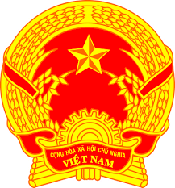
Statement of the Socialist Republic of Viet Nam
At the 36th Session of the UPR Working Group
Review of Belarus
(Geneva, 02 November 2020, 9:00-12:30)
Delivered by Ms. NGUYEN Phuong Anh, Deputy Permanent Representative

Time: 01 minute 10 seconds
Madam President,
Viet Nam thanks the delegation of Belarus for its presentation today.
We welcome the progress made by Belarus on many fields, including health services, education, decent work conditions and protecting the rights of vulnerable groups…
We recognize the strong commitment of Belarus to core international human rights treaties since the second cycle of the UPR, notably the entry into force of the Convention on the Rights of Persons with Disabilities on 29 November 2016.
In a spirit of constructive dialogue, Viet Nam makes the following recommendations to Belarus:
1. Take further measures aimed at the implementation of the Sustainable Development Goals, including from a human-rights perspective.
2. Continue strengthening its cooperation with thematic procedures of the Human Rights Council and providing them with the information upon requests.
Finally, we wish Belarus every success with this UPR cycle.
I thank you, Madam President./.

